Eportfolio Work Teams
- Timeline: four meetings 9-11:00 AM Wednesday November 13 – Wednesday December 4, 2013.
- Teams will gather for a brief plenary in I-208 each week then disperse to work on tasks, reconvening in i208 at 10:35 to hear feedback from team leads who will report on the Work Team’s progress.
- Each Work Team will structure its work around “Eportfolios as methods of assessing and demonstrating the College’s Institutional Learning Outcomes: Communication, Collaboration, Critical Thinking, Continuous Learning, Responsible Citizenship. For example:
Pedagogy Team will create assessments appropriate for each of the five folios.
Technology Team will create eportfolio templates clearly illustrating the five folios.
Communication Team will create messaging on the value of eportfolios for demonstrating the five skill sets of Mohawk Graduates
Pedagogy Work Team: Eportfolios as a Process
Suggested Members: Lisa, Peggy, Leah, Joanne
Objectives:
- Develop supports and strategies for faculty that help them to understand the role of eportfolios in learning and assessment, specifically:
  - Support for reflective practice - what reflections are and their role in eportfolio development and assessment (note: are there ‘service courses’ that could help us (e.g. CIT) – 68 LS faculty are not rolling out EPs – how can they support the writing/reflective piece?);
  - Understanding of the difference between ‘process and product’ as these relate to eportfolio development – eportfolio use as documentation of learning journey and to get a job;
- Consider semantics and how to communicate these to various programs (e.g. “reflections” may not mean anything to Eng. Tech) and finding champions in each program to develop model of use of EPs, assessment, etc.
- Other?
- Note: Valerie and Jenn will keep track of early adopters and communicate status to team.

Communications Work Team: Eportfolios as a Process AND a Product
Suggested Members: Julie, Lex, Cathy O., Margaret
Objectives:
- Develop communication strategy for all Mohawk Employees and Students.
- Include in strategy, who needs to know what when and how (see sample matrix):
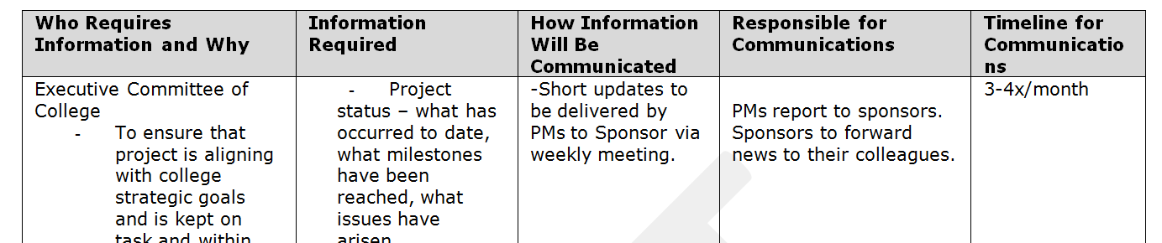
- Develop a chronological list of communications with recommendations for their production and distribution. Communication Timeline: December 1 – April 20, 2014
- Note: Valerie and Jenn will keep track of early adopters and communicate status to team.
Training & Technical Requirements Work Team: Eportfolios as a Product
Members: Jeff, Kathy, Dawn
Objectives:

- Create eportfolios templates (number to be determined by you) that present artefacts in five folios labelled/branded: Communication, Collaboration, Critical Thinking, Continuous Learning, Responsible Citizen.
- Develop consistent, college-wide approach to training and implementation through two tracks: 1 Within Learning Environments: Classrooms, Labs 2. Outside Learning Environments: not Classrooms or Labs.
- Consider and determine role of Student Services, CTL, Library and Tech Bar, Peer Tutors, Communication Centre, etc. in the approach.
- Note: Valerie and Jenn will keep track of early adopters and communicate status to team.

Project Coordination Team
Members: Valerie & Jenn
Objectives:
- Coordinate Common Hour events from late Nov. – early Dec. around eportfolios;
- Ensure we are meeting 30% target – communicate with ADs re: target and programs adopting;
- Communicate project status to sponsor and project team (regarding targets met, progress, etc.);
- Coordinate project assessment;
- Coordinate project work teams and workflow.
Post Script
- We have not included deliverable “obtain employer feedback from Advisory Groups, focus groups with employers, etc.” – this has been moved to a Winter Work Team deliverable.

